**VECTOR AND SCALAR QUANTITIES**

. A **SCALAR** is quantity that has MAGNITUDE, but NOT a direction associated with it.

Magnitude – A numerical value with units.

|  |  |
| --- | --- |
| SCALAR QUANTITIES | MAGNITUDE |
| Speed | 20 m/s |
| Mass | 1 kg |
| Volume | 10 m3 |
| Distance | 10 m |

Examples:

SCALAR ADDITION follows ordinary arithmetic procedures.

Ex: Mass: 10kg + 5kg = 15kg

Length: 20m - 10m = 10m

A **VECTOR** is quantity that has BOTH MAGNITUDE and DIRECTION.

|  |  |  |
| --- | --- | --- |
| VECTOR QUANTITIES | MAGNITUDE | DIRECTION |
| Velocity | 20 m/s | North |
| Acceleration | 10 m/s2 | East |
| Force | 5 N | West |
| Displacement | 10 m | South |

Examples:

VECTOR ADDITION uses special methods which are not arithmetic. The particular method used depends on the orientation of the vectors and how many vectors are being considered.

**BASIC CONCEPTS ABOUT VECTORS**

1. **VECTOR NOTATION**

* Vectors are typically represented by a **CAPITAL BOLD LETTER** or drawing an $\vec{ARROW}$ above the symbol. The arrow is used to convey direction and magnitude.

**F** or $\vec{F}$ = a vector of magnitude||or F and in a certain direction

$\vec{F}$ = 30N due south

Direction

Magnitude

1. **GRAPHICAL REPRESENTATION OF A VECTOR**

* Vector quantity is represented graphically by an arrow

Tail or foot tip or head (direction)

Magnitude

* the length represents magnitude
* the arrow faces the direction of motion

**Specifying Directions of Vectors:**

**Method 1.** Use the angle that the vector makes with the “zero degree reference line”.

$\vec{A}=20 km {30}^{o}$

$$\vec{B}=30 km {280}^{o}$$

**Method 2.** Use the geographical directions.

$\vec{A}=20 km {30}^{o} N of E$

$$\vec{B}=30 km {S 10}^{o} E$$

1. **COLLINEAR AND COPLANAR VECTORS**

* Collinear vectors – vectors lying on the same line

N

Ex: $\vec{F}$ = 30N due east $\vec{A}$ $\vec{F}$

W

E

$\vec{A}$ = 20N due west

S

* Coplanar vectors – vectors lying on the same plane

N

Ex: $\vec{F}$ = 30N 60O N of E or E 60O N $\vec{F}$

$\vec{A}$ = 20N 45O S of E or E 45O S

60O

W

E

45O

S

**ADDITION OF VECTORS**

**Resultant, R:** a single vector which would have the same effect as all the original vectors taken together.

**Equilibrant, E:** a single vector which has the same magnitude as the resultant but opposite in direction.

+ means vector $\vec{A}$ and $\vec{B}$ are to be added

+ – means vector $\vec{C}$ is to be subtracted from the sum of vector $\vec{A}$ and $\vec{B}$

1. **GRAPHICAL SOLUTION**
2. ***Parallelogram*** – for two vectors that are non-collinear but coplanar
3. ***Polygon (Tip-to-Tail) Method*** - suggested to be used for two or more vectors which are non-collinear but coplanar

The goal is to draw a *mini version* of the vectors to give an accurate picture of the magnitude and direction.

1. Pick appropriate scale.
2. Use a ruler & protractor, draw 1st vector to scale in appropriate direction.
3. Start at tip of 1st vector, draw 2nd vector to scale.
4. Connect the vectors starting at the tail end of the 1st and ending with the tip of the last vector. This is the sum of the vectors; it’s called the resultant vector, **R**.
5. Measure the magnitude of **R** with a ruler and convert this length to its actual amount and unit.
6. Measure the direction of **R** with a protractor and add this value along with the direction after the magnitude.
7. **ANALYTICAL SOLUTION**
8. ***Algebraic Method*** – for vectors which are collinear

* Sum (Resultant Vector), **R** = algebraic sum of the vectors

**R** = ∑Vectors

Ex: Add the following concurrent forces (acting at the same point)

**A** = 100N due East

**B** = 80N due West

**C** = 60N due West

**D** = 50N due East

1. ***Triangle Method*** – for two vectors that are non-collinear but coplanar

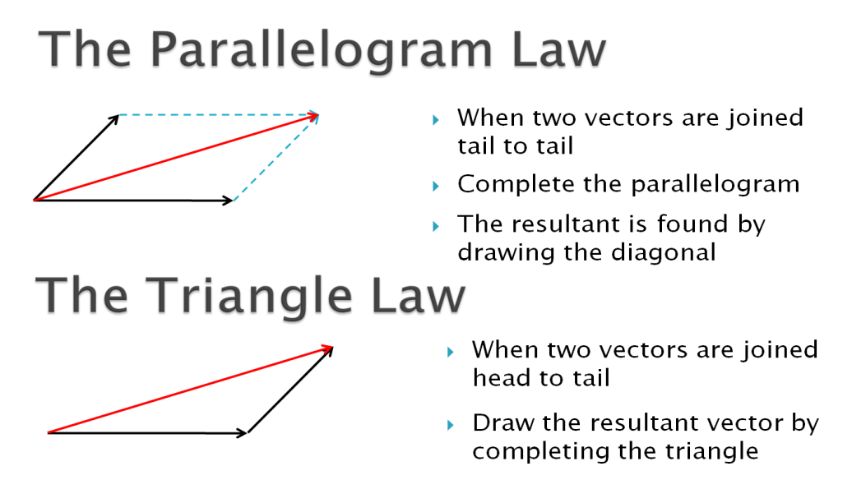

R

* The two vectors are joined head to tail
* Draw the resultant vector by completing the triangle.
* If the triangle formed is a right triangle, solve **R** by using Pythagorean Theorem and the trigonometric identities.

Pythagorean Theorem: c2 = a2 + b2

c

b

a

* If the triangle formed is not a right triangle, solve **R** using sine and cosine law.

Cosine Law: c2 = a2 + b2 -2abcos(C)

A

Sine Law: $\frac{a}{sin⁡(A)}= \frac{b}{\sin\left(B\right)}= \frac{c}{sin⁡(C)}$

b

c

B

C

a

1. ***Component Method*** – for two or more vectors which are non-collinear

i. Resolve the vectors into their x- and y-components.

ii. Add the x and y-components.

iii. Compute for the magnitude and direction of the Resultant Vector.